<======================================================================>

**LAMP Stack Apache - PHP Part 1/2**

<======================================================================>

By: @geraldopcf  
Date: 20, May, 2021  
Ubuntu Server 20.10

**INSTALL APACHE 2:**

sudo apt-get update

sudo apt-get install apache2

sudo service apache2 status

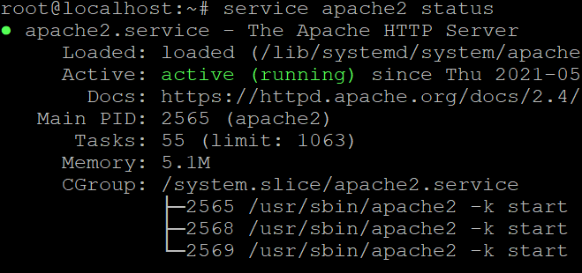

In the Apache Full profile, make sure it allows the traffic on ports 80 and 443. Check this by typing the command:  
  
sudo ufw app info “Apache Full”

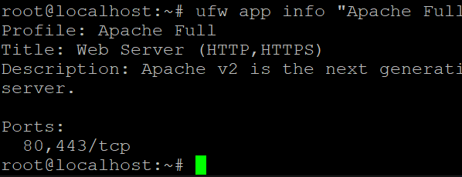

Testar no brower: <http://66.228.52.49/>

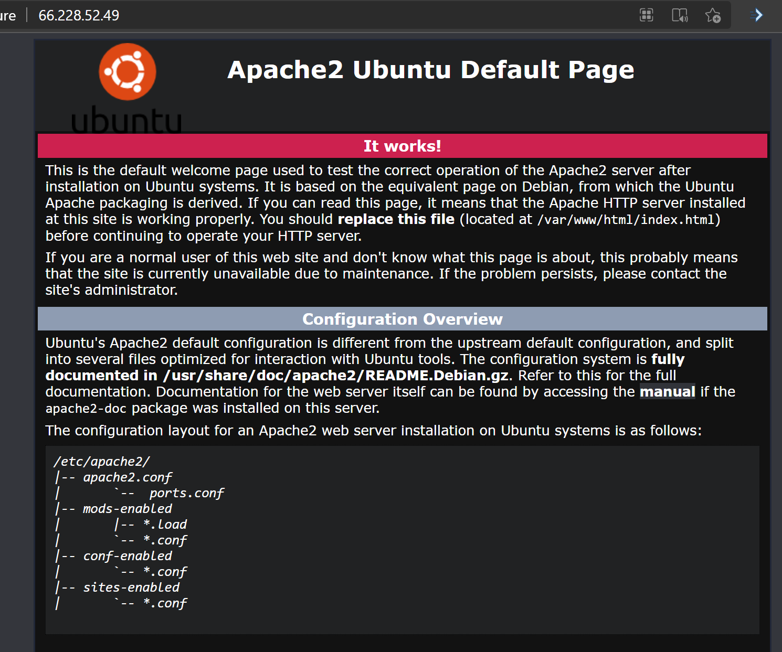

Note: To identify the server’s public IP address, run the command:

sudo apt-get install curl

curl http://icanhazip.com

**Install PHP (lite)**

sudo apt-get install php libapache2-mod-php php-mysql

**Install PHP (Full)**

sudo apt install php libapache2-mod-php

sudo apt-get install php7.4-cli php7.4-mysql php7.4-gd php7.4-imagick

sudo apt install php php-cli php-fpm php-json php-common php-mysql php-zip php-gd php-mbstring php-curl php-xml php-pear php-bcmath

sudo a2enmod proxy_fcgi setenvif  
sudo a2enconf php7.4-fpm  
sudo systemctl reload apache2

**Test PHP Processing on Web Server**

sudo nano /var/www/html/info.php

Inside the file, type in the valid PHP code:

<?php

phpinfo ();

?>

Open a browser and type in your IP **address/info.php**

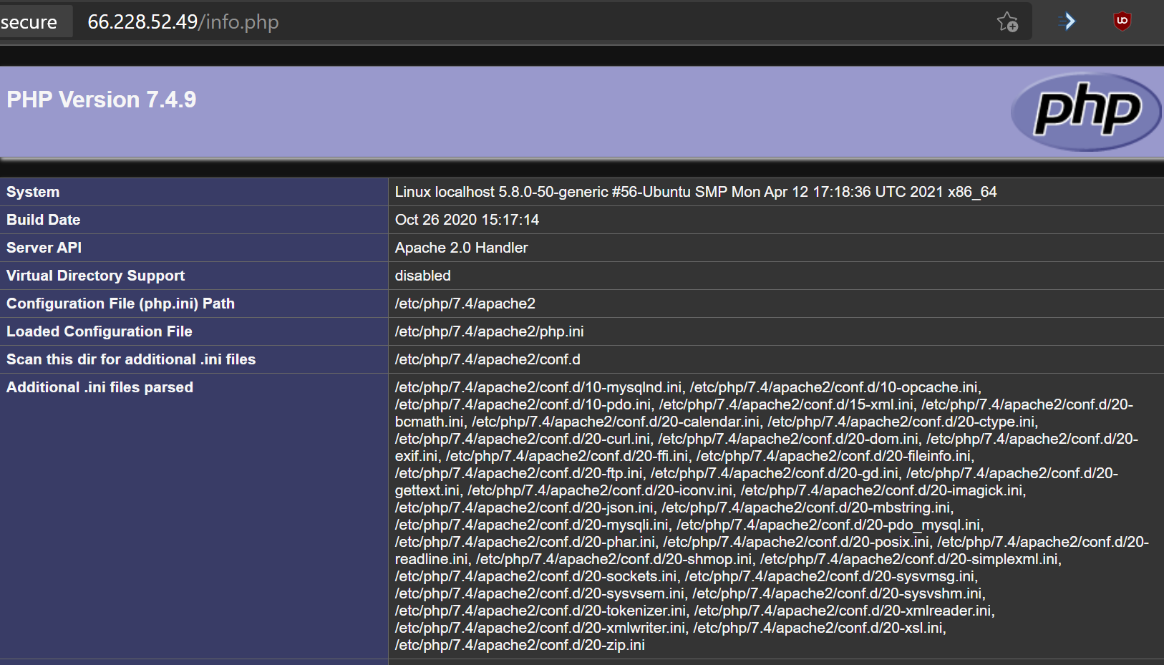

Ref: [How to Install LAMP Stack on Ubuntu 18.04 | PhoenixNAP KB](https://phoenixnap.com/kb/how-to-install-lamp-stack-on-ubuntu)

[**LAMPP Wordpress + PhpMyAdmin Part 2/2 - Google Docs**](https://docs.google.com/document/d/1G88y8P6G4n1tFpJldmud9oqlrdaVvQ4Y5CAfU1-Zl1k/edit)